Lab 2. Ransomware analysis using IDA and OllyDbg
Tools used:
1. IDA
2. OllyDbg 2.0.1

Scenario: Let's say you work for a malware analysis company. Today, we have a customer who sent us a ransomware sample ‘legionsample’, a ransom note ‘read_this_file.txt’, and a file encrypted by this ransomware. They ask us to decrypt the encrypted file on their system, as well as other files. This is going to be our task in this lab.

2.1. Perform some static analysis
First, check the ransom note:
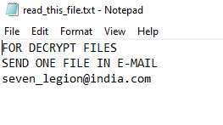

This malware sample is almost certainly ransomware and this is useful information. We also see the encrypted .png file, which the filename is changed according to a pattern.
Checking the malware sample with Detect-it Easy, we see that it’s a PE compiled by Microsoft Visual C/C++ compiler, and in the overlay there seems to be an image.
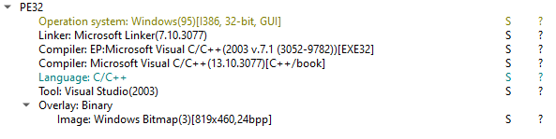

Check the sample with strings.exe, we see many interest strings:
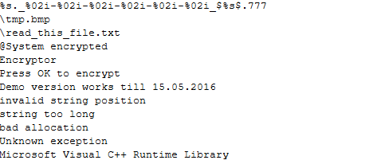
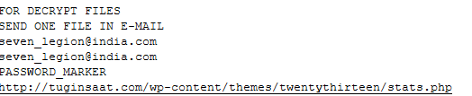

Before we continue, use the static analysis knowledge you have learned to analyze this sample and write down some hypotheses about it. Also, use Detect-it Easy to dump the overlay and get the .bmp file.

2.2. Disassembling the sample using IDA
Load the sample in IDA, in default we jump to the main function.
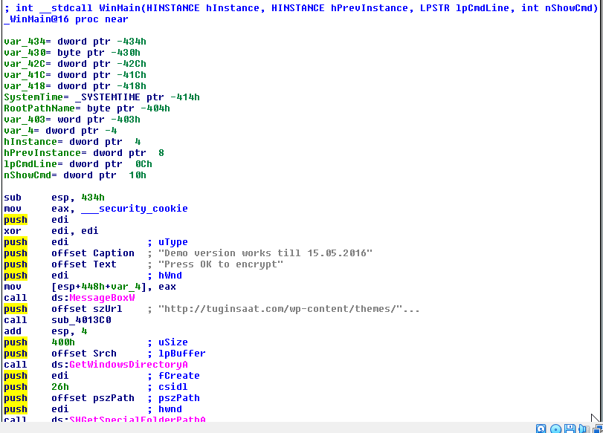
Press F5 to see the Pseudocode.
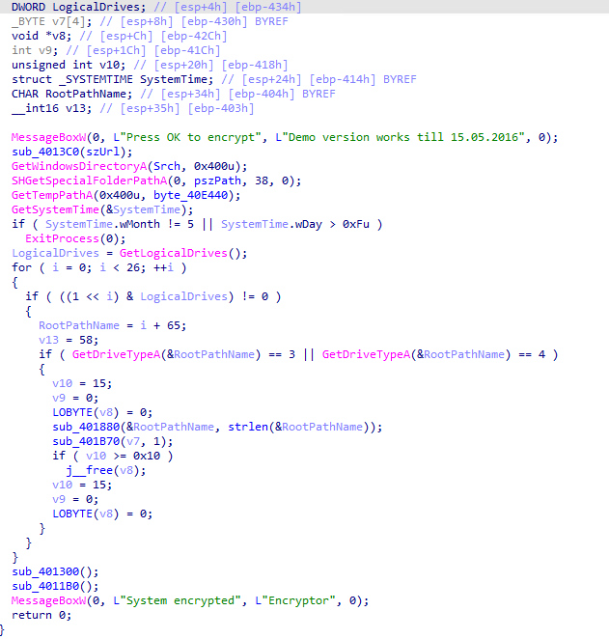

At the moment, we already know that this sample is a ransomware, so it will probably search for some drives and encrypt some data. But maybe is it just a demo version and doesn’t actually works, because now is 2024 and it says ‘Demo version works till 15.05.2016’.

Right below we see this code snippet. This code snippet shows that the only time this code can actually execute is from May 1st to May 15th, and the year doesn't matter.
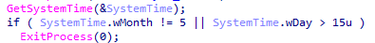

Now, we need to find the encryption function. A great place to find that is in loops, so the encryption function is most likely in this snippet:
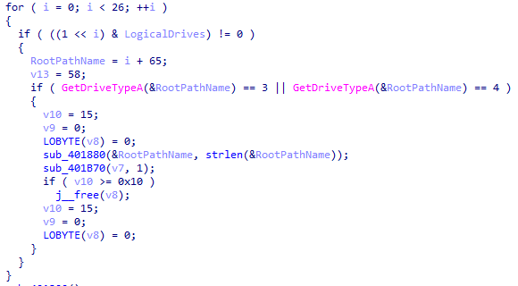

We can see there are 2 unnamed functions: sub_401880 and sub_401B70. Both of them could be the target function we are looking for.
Question 1: What is the purpose of function sub_401880?
The function sub_401880 is a C++ std::string assignment routine.
It copies a specified number of bytes from a source buffer into a std::string object, handling memory allocation, small-string optimization, and null termination.
This function is used to build or modify file paths and filenames during the ransomware execution.
Question 2: What is the purpose of function sub_401B70?
The function sub_401B70 recursively enumerates directories and files using Windows file APIs.
It filters out specific file types and system-related extensions, and for each eligible file, it calls the encryption routine.
This function acts as the main file traversal and encryption dispatcher of the ransomware.

The other things we can search for is imports. WriteFile from Kernel32.dll is widely used by ransomware to encrypt files directly on the system. We can see this API referenced frequently in the code.

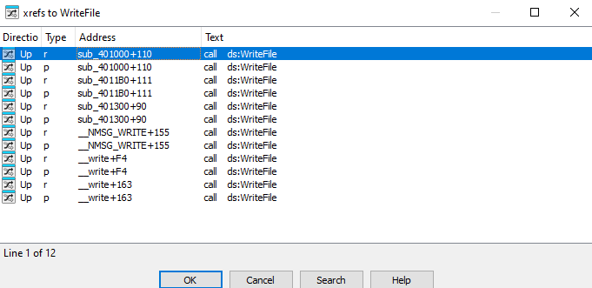

Let’s start with sub_401300 function.
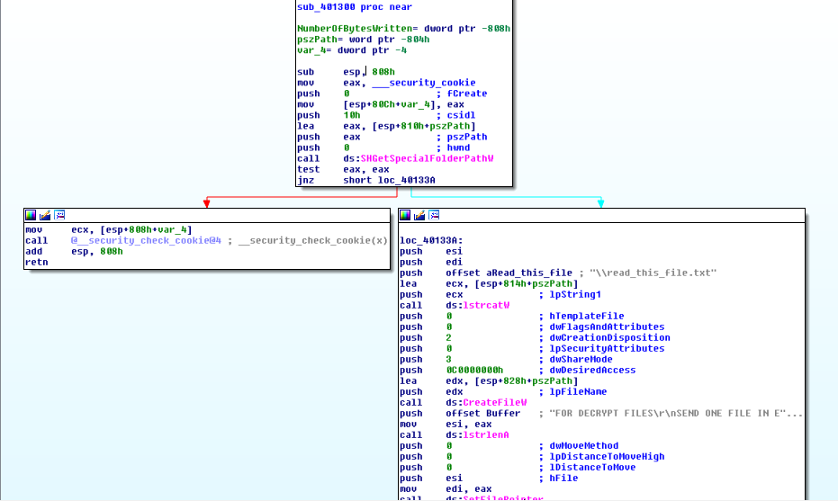
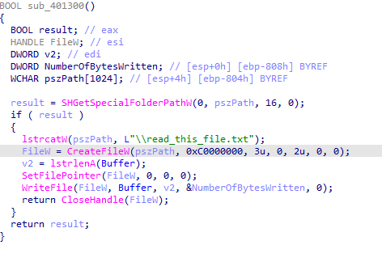

We already know about ‘read_this_file.txt’ file, so this function is just the ransom note writing function. Rename this function for easy recognition later.
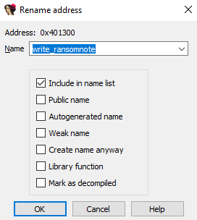

Now, looking at sub_4011b0 function. We can see ‘tmp.bmp’ file is being written, so this is also not an encryption function. Change the function name to ‘write_tmp_bmp’.
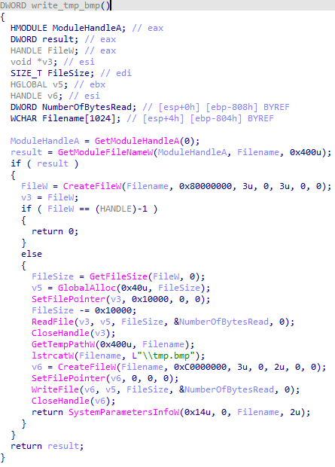

Now, looking at sub_401000 and this function is more interesting. We can see this code snippet which create a create a file with a file name pattern very similar to the encrypted file that the customer sent us. The input parameter lpString is the original file name.
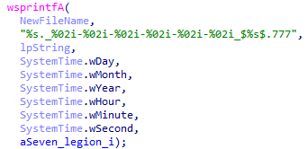

The question now is where the encryption happening in this function. This function contains several loops that we can investigate. The first loop doesn't look like it's doing encryption but just counting.
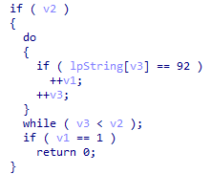

Looking at the second loop, we can see that it is performing the encryption of each byte of the file. Point out the address containing that encryption instruction and state the purpose of the sub_401000 function. Then, rename the function to file_encrypt.
Question 3: Explain the encryption algorithm

The encryption algorithm is a simple XOR-based encryption.
The malware reads the entire file into memory and XORs each byte with the constant value 0x37. This operation modifies the original file content in place.
XOR encryption is symmetric, meaning the same operation with the same key (0x37) can be used to decrypt the file. After encryption, the file is renamed with a timestamp and the .777 extension to mark it as encrypted.

Now there is still one problem to execute legion ransomware that has been mentioned and that is system time. We will patch the ransomware so that it runs regardless of the current date. Open the sample in OllyDbg and search for address 00401f6e, where the date check performed.

Select 4 instructions to perform the test, then right click, select Edit -> Fill with NOPs to delete these instructions.
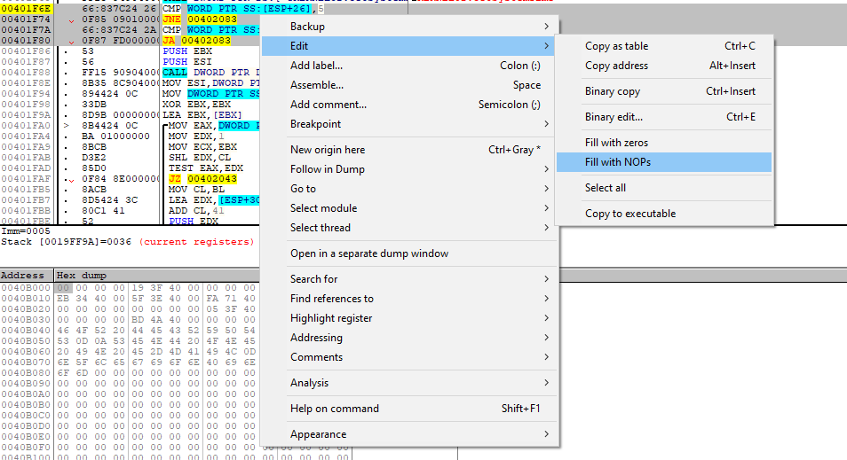

To save the new patched ransomware, right click and select Edit -> Copy all modifications to executable. On the new window, right click and select Save file. Then enter the new file name and click Save. Now, we have a patched ransomware sample that we can execute regardless of the current date.

Now it's time to test this malware. Disconnect the virtual machine from the network and create a snapshot. Then feel free to run it :). It will take about a few ten minutes for the encryption to complete. You will see all of the files in your device have been encrypted.

Interestingly, the encrypted image file that the customer sent us can now be opened normally. Based on the encryption mechanism of this ransomware sample, explain this.

Do more analysis on this malware and write a conclusion about it.
Question 4: Summarize the functions of this malware
This malware functions as a simple ransomware-like file encryptor. Its main behaviors are:
- Scans and opens a target file.
- Reads the entire file into memory.
- Encrypts the file content using a byte-wise XOR with key 0x37.
- Overwrites the original file with the encrypted data.
- Renames the file using a timestamp-based format and adds the .777 extension.
- Marks encrypted files to indicate successful infection.

Question 5: Write a program to decrypt the encrypted files which this malware encrypted.
Since XOR is symmetric, decryption is identical to encryption.
Python decryption example
```
def decrypt_file(filename):
with open(filename, "rb") as f:
data = bytearray(f.read())

for i in range(len(data)):
data[i] ^= 0x37

with open(filename, "wb") as f:
f.write(data)

print("Decrypted:", filename)

# Example usage
decrypt_file("encrypted_file.777")
```

